license plate recognition based on image processing

Carson Wagner

School of Electrical and Computer Engineering
University of Oklahoma, Norman, OK, 73069
Email: CarsonWagner19@ou.edu

Abstract

License plate recognition is crucial for detecting vehicle owners for traffic violations or border immigration. The recognition of license plate numbers is done through the performance of optical character recognition. Images were put through thresholding and minor region removal to extract the license plate from the original image. This image is then cropped to fully display the license plate for reading and for the use of optical character recognition. The performance of OCR is calculated through multiple trials of reading license plates after the images have gone through methods of gray scaling, thresholding, and minor region removal. The accuracy of the OCR is crucial to license plate recognition, matching the vehicle to the correct owner. Template matching is heavily used for OCR to read the individual characters of the license plate number. The goal of license plate recognition is to provide an accurate method of detecting vehicle ownership using previous and newly developed techniques.

1. Introduction

License plate recognition is beneficial to cities and companies to track down anyone who shouldn’t be parked in their parking lot or catching anyone who breaks a law. License plate recognition has taken a lot of trial and error. A lot of work has been completed on this project such as turning a RBG jpeg image of a car with its license plate into a grayscale image. Secondly, this image was thresholded and then blob coloring was done on the thresholded image to remove noise. Lastly, blob counting and minor region removal was done on the car to furthermore remove unneeded noise in the vehicle image. The resulting image of minor region removal was then used to extract the license plate from the original image. The extracted image of the license plate was cropped to fully display the license plate for reading the license plate number.

2. BACKGROUND

The Yilmaz [1] method of optical character recognition used an already cropped image of the license plate and began by thresholding the image and blob extraction to make the characters easily extractable. Yilmaz [1] used another technique by checking the connectivity of the pixels and measured the centroid and found the maximum object area of where centroids were horizontally central region in the extracted plate. This region became an inner rectangle that had sizes that were within 5% from the left and right and 25% from up and down border of the plate. This is where the OCR was then used on the extracted binary image to detect the license plate number. Yilmaz [1] had specific rules for blob checking characters which consisted of selecting blobs that were within the centroid falling to the predefined central region. Select objects which is in the range by the equation (1) A_{Max} is the maximum central blob area

$$0.5*A_{Max}<A_{Selected}<{1.5*A}_{Max} (1)$$

If the width of the blob is bigger than ¼ of the average of all blobs, then it is a connected character and will be further segmented. Lastly if the number of successful blocks is more than 8 or less than 3, then the blob needs to be checked again.
Ygoheedha, Nasir, Jaafar, Mamduh [2] method of OCR based on template matching was done by using test data of characters ranging from 0 through 9 and A through Z. This process was done by analyzing the bounding box of the images and then outputting the data of characters. Pictures were taken of three different vehicles and were grayscaled, thresholded, noise removed twice, minor region removed, and then the image was cropped to show the image of the license plate to enable template matching to be used.

3. Methodology

The first task was completed and involved taking numerous photographs of cars and license plates. Texas plates were used due to the simplicity of their design as other state’s plates have some aspects that make the image too difficult to read and would need more serious image processing. After finalizing this decision and taking photographs of Texas license plates, the images were converted into a 256x256 RGB jpeg image.

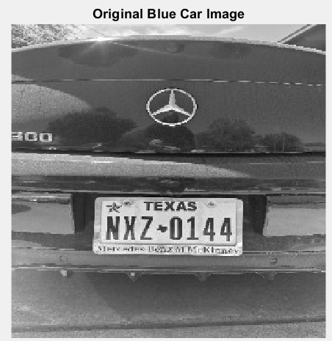

This image was read and then converted into a 256x256 grayscale image and displayed through MATLAB. Secondly, this grayscale image was put through thresholding using the equation (2)

$$J=255*\left(BlueCar≥threshold\right) (2)$$

Where J is the thresholded image and BlueCar is the grayscale image of the vehicle and threshold was a value that was found through analyzing the thresholded image. The best value of threshold was found to be 130 through trial and error, this value gave the best image to put through blob coloring
.
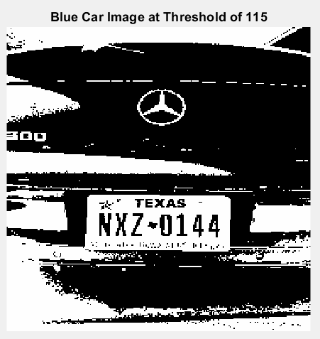

After finding the best value for thresholding the image, the thresholded image was put through blob coloring to detect regions within the image that differ in brightness compared to other surrounding areas of the image. This is used in preparation for Yogheedha, Nasir, Jaafar, Mamduh [2] noise removal and image subtraction method. Combing this method with Havlicek [3] method of minor region removal. The following image is the thresholded image after blob coloring has been applied.

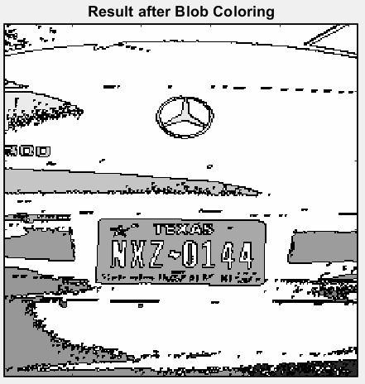

Blob coloring allowed Havlicek’s [3] process of minor region removal to be done to the image where the image below is the result that was found.

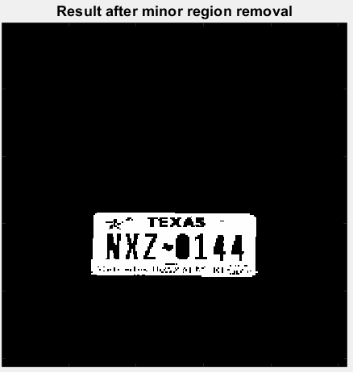
This doesn’t allow the image to be read using Yilmaz[1] optical character recognition method. So, the next step was to do further minor region removal to extract the license plate image to allow for OCR. The image below is the minor region removal result that was found by inverting the image and repeating blob coloring and minor region removal.

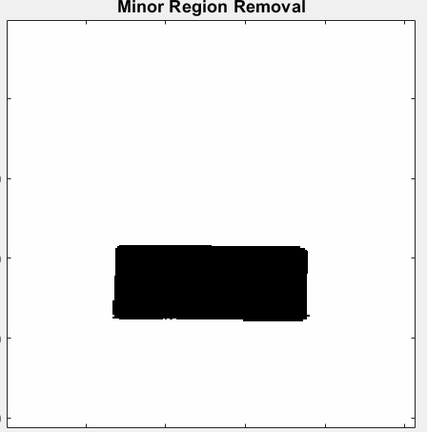

The final minor region removal result was found by using equation (3) below,

$$y=255-x (3)$$

Where y is the final result of minor region removal and x is the minor region removal image shown previously. The resulting image is shown below,

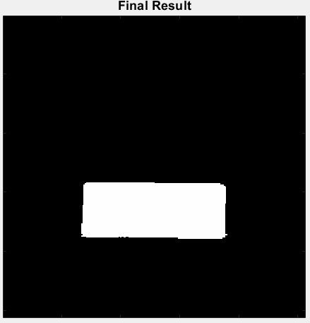

The final license plate image was found using the equation (4) where y is the final license plate image, x is the final minor region removal image, and BlueCarDouble is the original BlueCar image converted into a 256x256 double array.

$$y=255-\frac{x .*BlueCarDouble}{255} (4)$$

The final result of the extracted license plate is the image below, showing the license plate extracted from the image to use for optical character reading

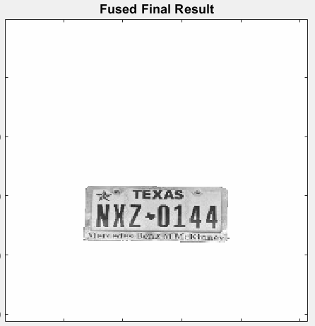

Lastly, the fused final result was cropped to zoom in on the license plate to prepare for optical character recognition. The image of the cropped license plate image is shown below,

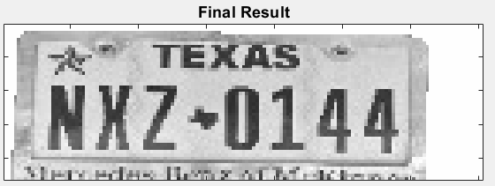

This is the final result of the license plate recognition system.

4. known issues

Unfortunately, using optical character recognition proved to be very difficult, as when attempting to use the built in MATLAB OCR functions, none of them proved to work. The first attempt at fixing this issue was to make the final cropped license plate result into a thresholded image for reading, secondly there were a variety of of ways to use the OCR MATLAB function one of which included using ROI and manually creating a rectangle around the image for the optical character recognition function to read the image which proved to be unsuccessful as. Each of these attempts gave an output of “License Plate Number: 0” which was incorrect. After trying over four different ways of using the OCR function it was decided that using the cropped license plate image result was the best option, thus the license plate recognition was finished.

5. Conclusion

The goal of this work is to enable companies, police, and cities to save time detecting license plates whether it’s for a traffic violation, border immigration, or other uses. The use of Yilmaz [1] method of optical character recognition after image cropping helps collect data of license plate numbers from a large picture of the vehicle being read was unsuccessful for this system, however in future work it can be introduced in this license plate system with further image processing. Through gray scaling, thresholding, blob coloring, minor region removal, image extraction, and image cropping the license plate recognition system was completed through image processing. Unfortunately, Ygoheedha, Nasir, Jaafar, Mamduh [2] method of using template matching for OCR was not successful, however, with further image processing it can be successfully completed. In future work, this license plate detection system could be done using computer vision to automatically detect the license plate and read the license plate number. As a result of the failed use of optical character recognition, the license plate was extracted from the image and this image was cropped to fully display the license plate for it to be visibly read. Future work of license plate recognition will be able to use the previous and new techniques of image processing.

6. References

[1] K. Yilmaz, "A smart hybrid license plate recognition system based on image processing using neural network and image correlation," 2011 International Symposium on Innovations in Intelligent Systems and Applications, Istanbul, Turkey, 2011, pp. 148-153, doi: 10.1109/INISTA.2011.5946087.

[2] K. Yogheedha, A. S. A. Nasir, H. Jaafar and S. M. Mamduh, "Automatic Vehicle License Plate Recognition System Based on Image Processing and Template Matching Approach," 2018 International Conference on Computational Approach in Smart Systems Design and Applications (ICASSDA), Kuching, Malaysia, 2018, pp. 1-8, doi: 10.1109/ICASSDA.2018.8477639.

[3] Joseph Havlicek, “Homework 6 Solution,” ECE 5273 Digital Image Processing

